1. **Mobile Application Development**

**(Android –Platform)**

# Android - Environment Setup



We can start our Android application development on either of the following operating systems −

* Microsoft Windows XP or later version.
* Mac OS X 10.5.8 or later version with Intel chip.
* Linux including GNU C Library 2.7 or later.

All the required tools to develop Android applications are freely available and can be downloaded from the Web. Following is the list of software's we will need before we start our Android application programming.

* Java JDK5 or later version
* Android Studio

## Set-up Java Development Kit (JDK)

We can download the latest version of Java JDK from Oracle's Java site − [Java SE Downloads](http://www.oracle.com/technetwork/java/javase/downloads/index.html). We will find instructions for installing JDK in downloaded files, follow the given instructions to install and configure the setup. Finally set PATH and JAVA_HOME environment variables to refer to the directory that contains **java** and **javac**, typically java_install_dir/bin and java_install_dir respectively.

If we are running Windows and installed the JDK in C:\jdk1.8.0_102, we would have to put the following line in our C:\autoexec.bat file.

set PATH=C:\jdk1.8.0_102\bin;%PATH%

set JAVA_HOME=C:\jdk1.8.0_102

Alternatively, we could also right-click on *My Computer*, select *Properties*, then *Advanced*, then *Environment Variables*. Then, we would update the PATH value and press the OK button.

On Linux, if the SDK is installed in /usr/local/jdk1.8.0_102 and we use the C shell, we would put the following code into our **.cshrc** file.

setenv PATH /usr/local/jdk1.8.0_102/bin:$PATH

setenv JAVA_HOME /usr/local/jdk1.8.0_102

Alternatively, if we use Android studio, then it will know automatically where we have installed our Java.

## Android IDEs

There are so many sophisticated Technologies are available to develop android applications, the familiar technologies, which are predominantly using tools as follows:

* [Android Studio](https://www.tutorialspoint.com/android/android_studio.htm)
* [Eclipse IDE (Deprecated)](https://www.tutorialspoint.com/android/android_eclipse.htm)

# Android - Studio

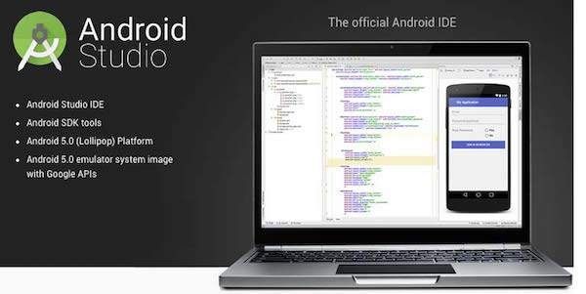

## Step 1 - System Requirements

We can start our Android application development on either of the following operating systems −

* Microsoft® Windows® 10/8/7/Vista/2003 (32 or 64-bit)
* Mac® OS X® 10.8.5 or higher, up to 10.9 (Mavericks)
* GNOME or KDE desktop

All the required tools to develop Android applications are open source and can be downloaded from the Web. Following is the list of software's we will need before we start our Android application programming.

* Java JDK5 or later version
* Java Runtime Environment (JRE) 6
* Android Studio

## Step 2 - Setup Android Studio

Android Studio is the official IDE(integrated development environment) for android application development.It works based on **IntelliJ IDEA**, we can download the latest version of android studio from [Android Studio 2.2 Download](https://developer.android.com/sdk/index.html), If we are new to installing Android Studio on windows,you will find a file, which is named as *android-studio-bundle-143.3101438-windows.exe*.So just download and run on windows machine according to android studio wizard guideline.

If we are installing Android Studio on Mac or Linux, we can download the latest version from [Android Studio Mac Download](https://dl.google.com/dl/android/studio/install/1.1.0/android-studio-ide-135.1740770-mac.dmg),or [Android Studio Linux Download](https://dl.google.com/dl/android/studio/ide-zips/1.1.0/android-studio-ide-135.1740770-linux.zip), check the instructions provided along with the downloaded file for Mac OS and Linux. Considering that you are going to setup our environment on Windows machine having Windows 8.1 operating system.

## Installation

So let's launch *Android Studio.exe*,Make sure before launch Android Studio, Our Machine should required installed Java JDK. To install Java JDK,take a references of [Android environment setup](https://www.tutorialspoint.com/android/android_environment_setup.htm)

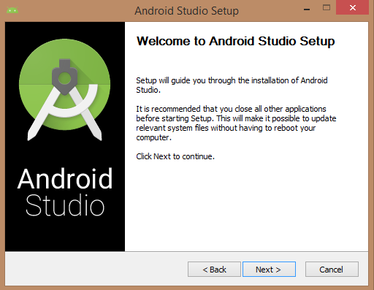

Once we launched Android Studio, its time to mention JDK7 path or later version in android studio installer.

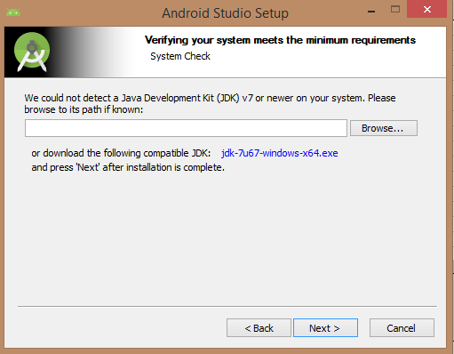

Below the image initiating JDK to android SDK

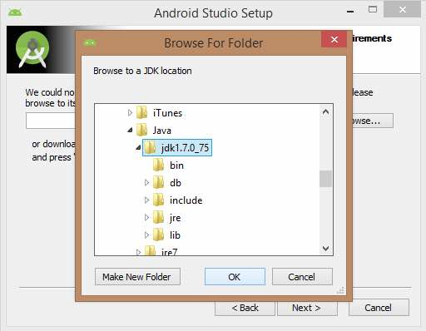

Need to check the components, which are required to create applications, below the image has selected **Android Studio**, **Android SDK**, **Android Virtual Machine** and **performance(Intel chip).**

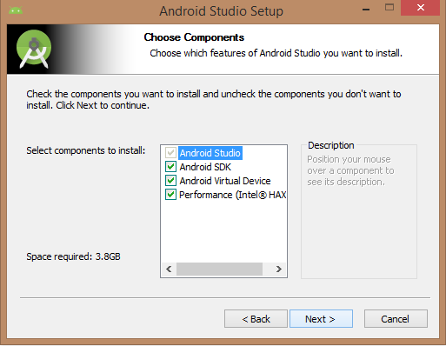

Need to specify the location of local machine path for Android studio and Android SDK, below the image has taken default location of windows 8.1 x64 bit architecture.

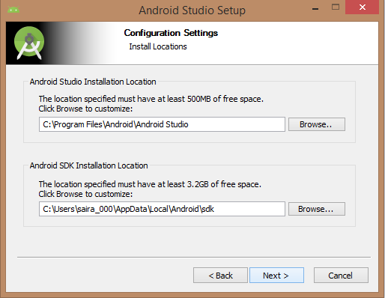

Need to specify the ram space for Android emulator by default it would take 512MB of local machine RAM.

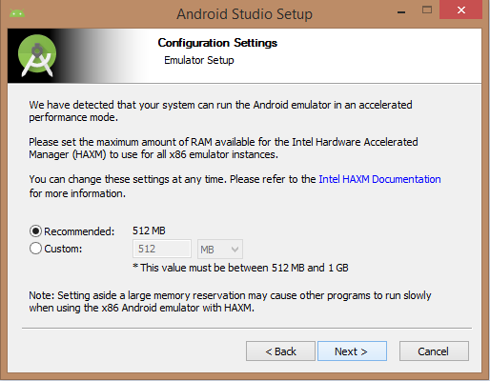

At final stage, it would extract SDK packages into our local machine, it would take a while time to finish the task and would take 2626MB of Hard disk space.

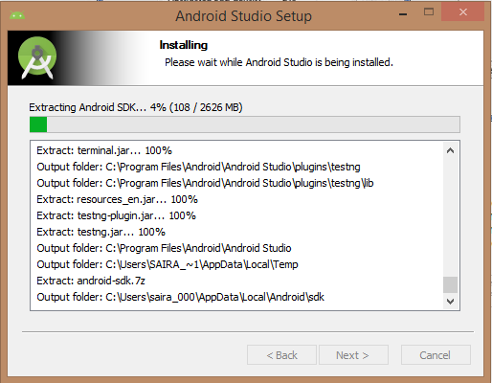

After done all above steps perfectly, we must get finish button and it gonna be open android studio project with Welcome to android studio message as shown below:

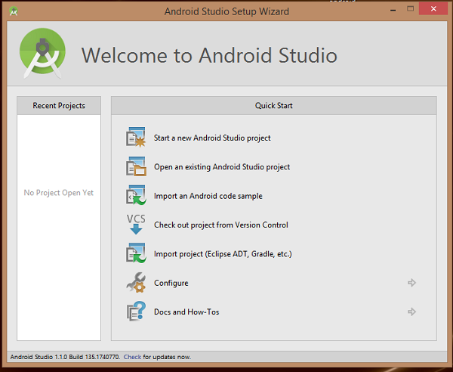

We can start our application development by calling start a new android studio project. In a new installation frame should ask Application name, package information and location of the project.

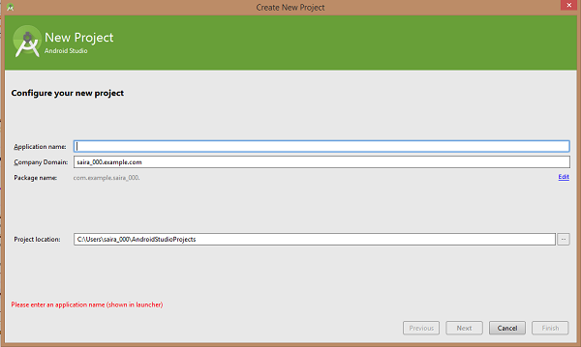

After entered application name, it going to be called select the form factors our application runs on, here need to specify Minimum SDK (ex. API23: Android 6.0(Mashmallow))

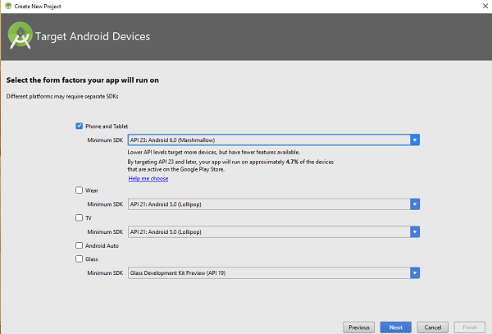

The next level of installation should contain selecting the activity to mobile, it specifies the default layout for Applications

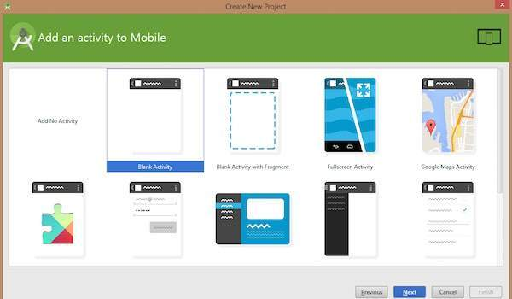

At the final stage it going to be open development tool to write the application code.

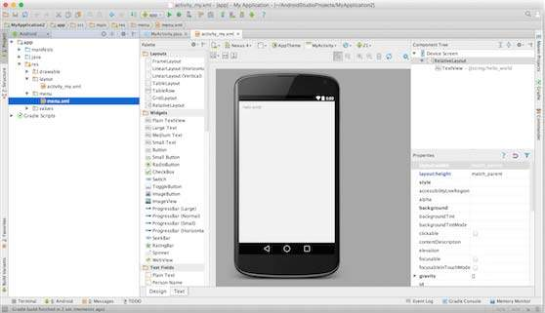

**Step 3 – Create Android Virtual Device (AVD)**

To test our Android applications, we will need a virtual Android device. So before we start writing our code, let us create an Android virtual device. Launch Android AVD Manager Clicking AVD_Manager icon as shown below

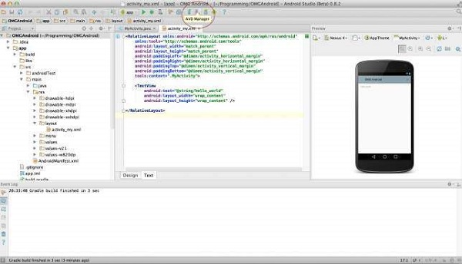

After Click on a virtual device icon, it going to be shown by default virtual devices which are present on our SDK, or else need to create a virtual device by clicking **Create new Virtual device** button

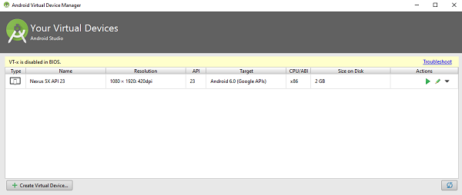

If our AVD is created successfully it means our environment is ready for Android application development. If we like, we can close this window using top-right cross button. Better we re-start our machine and once you are done with this last step, you are ready to proceed for our first Android example but before that we will see few more important concepts related to Android Application Development.

## Hello Word Example

Before Writing a Hello word code, we must know about XML tags.To write hello word code, we should redirect to **App>res>layout>Activity_main.xml**

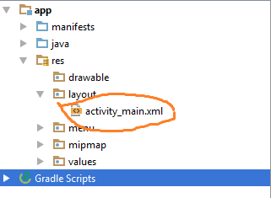

To show hello word, we need to call text view with layout (about text view and layout, we must take references at [Relative Layout](https://www.tutorialspoint.com/android/android_relative_layout.htm) and [Text View](https://www.tutorialspoint.com/android/android_textview_control.htm) ).

<RelativeLayoutxmlns:android="http://schemas.android.com/apk/res/android"

xmlns:tools="http://schemas.android.com/tools"android:layout_width="match_parent"

android:layout_height="match_parent"android:paddingLeft="@dimen/activity_horizontal_margin"

android:paddingRight="@dimen/activity_horizontal_margin"

android:paddingTop="@dimen/activity_vertical_margin"

android:paddingBottom="@dimen/activity_vertical_margin"tools:context=".MainActivity">

<TextViewandroid:text="@string/hello_world"

android:layout_width="550dp"

android:layout_height="wrap_content"/>

</RelativeLayout>

Need to run the program by clicking **Run>Run App** or else need to call **shift+f10** key. Finally, result should be placed at Virtual devices as shown below

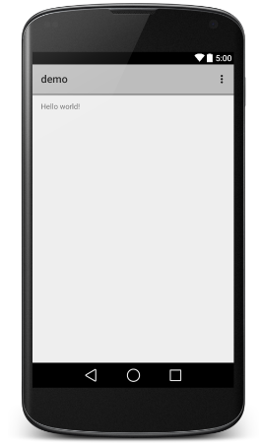

# Android – Eclipse IDE (Deprecated - acknowledged but discouraged)



### Set-up Android SDK ([Software Development Kit)](https://www.androidauthority.com/how-to-install-android-sdk-software-development-kit-21137/))

We can download the latest version of Android SDK from Android official website − [Android SDK Downloads](http://developer.android.com/sdk/index.html). If we are installing SDK on Windows machine, then we will find a *installer_rXX-windows.exe*, so just download and run this exe which will launch *Android SDK Tool Set up* wizard to guide we throughout of the installation, so just follow the instructions carefully. Finally we will have *Android SDK Tools* installed on our machine.

If we are installing SDK either on Mac OS or Linux, check the instructions provided along with the downloaded *android-sdk_rXX-macosx.zip* file for Mac OS and *android-sdk_rXX-linux.tgz* file for Linux. Consider that we are going to set up our environment on Windows machine having Windows 7 operating system.

So let's launch *Android SDK Manager* using the option **All Programs > Android SDK Tools > SDK Manager**, this will give we following window −

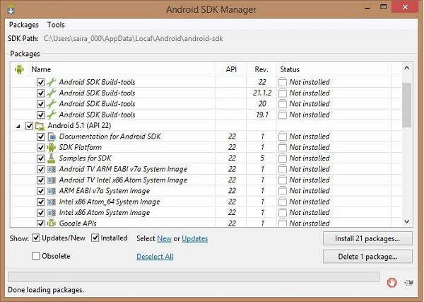

Once we launched SDK manager, its time to install other required packages. By default it will list down total 7 packages to be installed, but suggestion is to de-select *Documentation for Android SDK* and *Samples for SDK* packages to reduce installation time. Next click **Install 7 Packages** button to proceed, which will display following dialogue box −

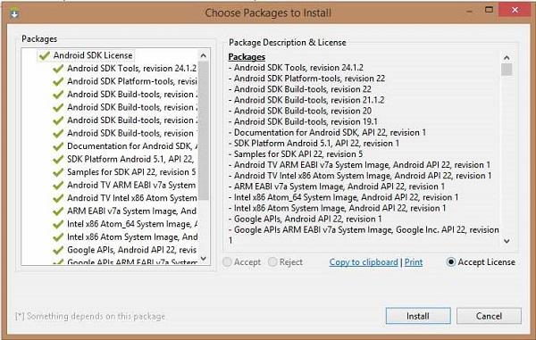

If we agree to install all the packages, select **Accept All** radio button and proceed by clicking **Install** button. Now let SDK manager do its work and we go, pick up a cup of coffee and wait until all the packages are installed. It may take some time depending on our internet connection. Once all the packages are installed, we can close SDK manager using top-right cross button.

## Set-up Eclipse IDE (Integrated Development Environment)

To install Eclipse IDE, download the latest Eclipse binaries from <https://www.eclipse.org/downloads/>. Once we downloaded the installation, unpack the binary distribution into a convenient location. For example in C:\eclipse on windows, or /usr/local/eclipse on Linux and finally set PATH variable appropriately.

Eclipse can be started by executing the following commands on windows machine, or we can simply double click on eclipse.exe

%C:\eclipse\eclipse.exe

Eclipse can be started by executing the following commands on Linux machine −

$/usr/local/eclipse/eclipse

After a successful start up, if everything is fine then it should display following result −

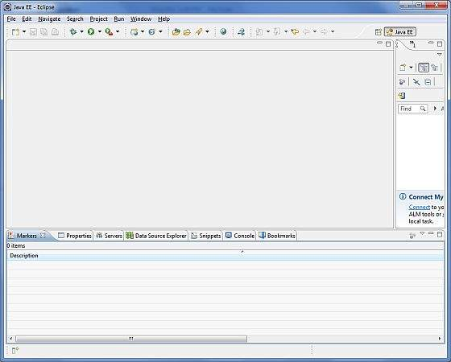

## Set-up Android Development Tools (ADT) Plug-in

This step will help us in setting Android Development Tool plug-in for Eclipse. Let's start with launching Eclipse and then, choose **Help > Software Updates > Install New Software**. This will display the following dialogue box.

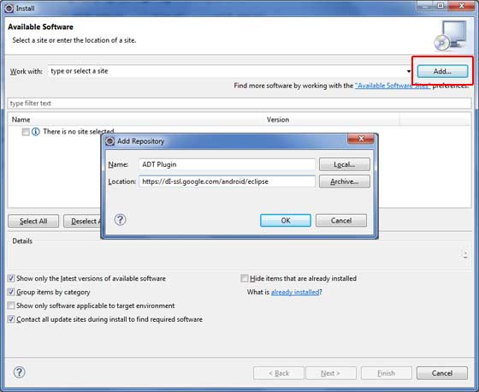

Now use **Add** button to add *ADT Plug-in* as name and *https://dl-ssl.google.com/android/eclipse/* as the location. Then click OK to add this location, as soon as we will click OK button to add this location, Eclipse starts searching for the plug-in available the given location and finally lists down the found plug-ins.

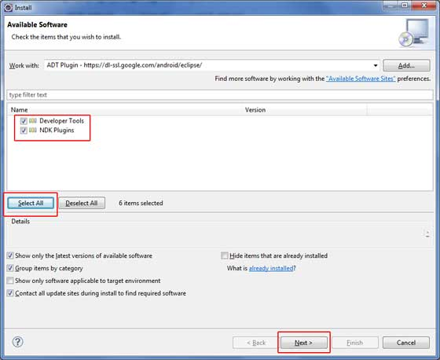

Now select all the listed plug-ins using **Select All** button and click **Next** button which will guide we ahead to install Android Development Tools and other required plug-ins.

## Create Android Virtual Device

To test our Android applications we will need a virtual Android device. So before we start writing our code, let us create an Android virtual device. Launch Android AVD Manager using Eclipse menu options **Window > AVD Manager>** which will launch Android AVD Manager. Use **New** button to create a new Android Virtual Device and enter the following information, before clicking **Create AVD** button.

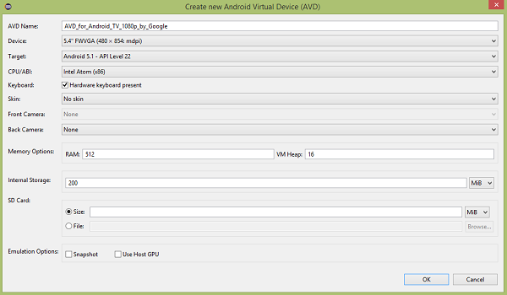

If our AVD is created successfully it means our environment is ready for Android application development. If we like, we can close this window using top-right cross button. Better we re-start our machine and once we are done with this last step, we are ready to proceed for our first Android example but before that we will see few more important concepts related to Android Application Development.

# 1. Android - Environment Setup

## Questions

* 1. Write two main sophisticated technologies for developing Android application and what are the requirements (hardware and software) to set-up Android studio.
  2. How to set-up Java Development Kit (JDK) for Android?
  3. How to set-up Android SDK (Software Development Kit) for Android??
  4. How to set-up Android Development Tools (ADT) Plug-in for Android??
  5. How to set-up Eclipse IDE (Integrated Development Environment) for Android?

[Minimum requirements (hardware and software)]